Lhakpa Wangyal

Social Baluni Public School

Haridwar Bye-pass road

Dehradun, Uttarakhand

October 25, 2020

The Principal

Social Baluni Public School,

Haridwar Bye-pass road

Dehradun, Uttarakhand

**Subject: Applying for ‘Casual Leave’ on October 26, 2020**

Sir,

With humble submission, I would like to inform your kind self that I had to visit Mussoorie on October 26, 2020 (Monday) in due reasons of some family matters. So, kindly grant me ‘Casual leave’ on the day.

Thanking you in anticipation.

Your sincerely,

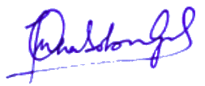

Lhakpa Wangyal

PGT Biology